Angel Society of Fallbrook
SCHOLARSHIP APPLICATION
Application for: (circle one) Graduating Senior/High School or Continuing College
STUDENT NAME________________________________________DATE_________________
STUDENT ADDRESS__________________________________________________________
STUDENT EMAIL___________________________CELL PHONE_____________________
NAME OF SCHOOL ATTENDING________________________________________________
*UNIVERSITY, COMMUNITY COLLEGE, OR VOCATIONAL SCHOOLS APPLYING: ____________________________________________________________________________________________________________________________________________________________________________________________________________________________________
Current weighted G.P.A. ________________
FATHER___________________________MOTHER__________________________________
NUMBER OF SIBLINGS IN YOUR HOUSEHOLD______
CURRENTLY IN COLLEGE_______________
HOW WILL YOU FINANCE YOUR EDUCATION? APPROXIMATE SUPPORT FROM: PARENTS_____________GRANTS/LOANS___________YOURSELF___________________
*SCHOOL ACTIVITIES (years participated, positions held)
___________________________________________________________________________________________________________________________________________________________________
*COMMUNITY SERVICE ACTIVITIES (years participated, positions held)
____________________________________________________________________________
____________________________________________________________________________
____________________________________________________________________________
*WORK EXPERIENCE (years worked, jobs held)
________________________________________________________________________________________________________________________________________________________
*Continue answers on back if needed

Continued from page 1

ATTACH PERSONAL ESSAY
Must be 250 words, double spaced
Describe yourself and your family
Indicate your educational, work and community service plans
INCLUDE ONE LETTER OF RECOMMENDATION
From teacher, coach, counselor, or community service supervisor
INCLUDE HIGH SCHOOL OR COLLEGE TRANSCRIPT
Official or Unofficial is accepted
MAIL ENTIRE PACKAGE TO:
Angel Society of Fallbrook
Attn: Philanthropy Chairman
P.O. Box 1408
Fallbrook, CA 92088

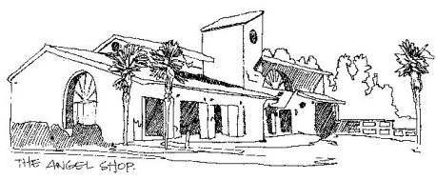
APPLICATION DEADLINES
March 1 for High School applications
Applicants must be high school seniors residing in the Fallbrook/Bonsall school districts, including online students.

June 1 for Continuing College applications
Applicants must be college students or their parents who reside in the Fallbrook or Bonsall school districts. Awardees of Continuing College scholarships may apply again, for not more than one additional year.

